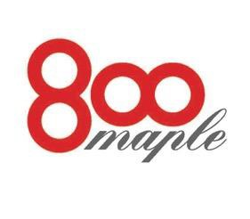
Banquet Luncheon Menu

800 Maple is available for private parties, showers, funeral luncheons, cocktail receptions, pharmaceutical dinners, corporate and social events. A $1,500.00 minimum, before tax and gratuity, is the required amount to host a party during non business hours.

Salads
Field greens with a red wine vinaigrette $ 7.95
Caesar salad the classic preparation $ 7.95
Arugula salad, roasted peppers, sweet corn, tomato and shaved Reggiano $ 8.95

Luncheon Selections  Chicken asaigo, stuffed chicken breast with asiago stuffing and marsala | $18.95
Chicken Milanese breaded and sautéed with an arugula salad | $18.95
Chicken breast stuffed with spinach, proscuitto and fontina cheese | $18.95
Chicken breast stuffed with a wild mushroom duxelle | $18.95
Caesar salad with grilled chicken or shrimp | $14.95/$17.95
Chicken salad with a sun dried tomato glaze and toasted pine nuts | $16.95
Farfalle pasta with asparagus, Portobello mushrooms and lemon zest | $16.95
Tagliatelle with grilled shrimp, tomato, olives, fennel and hot peppers | $19.95
Penne Romano with chicken, prosciutto, peas in a Romano cream sauce | $18.95
Rigitoni with spicy Italian sausage, calamata olives and plum tomatoes | $17.95
Pork tenderloin with a potato crust and sun dried tomato demi glace | $21.95
Sliced beef tenderloin roasted with a Barolo wine sauce | $32.95

Desserts
All of our desserts are made in house and include cakes, tortes, and specialty chocolate desserts. Please inquire with your catering manager.
*We would be glad to host your next event; please call 688-5800 for information

