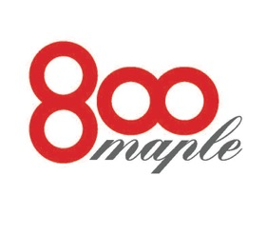
Banquet luncheon menu

800 Maple is available for private parties, showers, funeral luncheons, cocktail receptions, pharmaceutical dinners, corporate and social events. A $1,000.00 minimum, before tax and gratuity, is the required amount to host a party during non business hours.

Salads
Field greens with a red wine vinaigrette $ 7.95
Caesar salad the classic preparation $ 7.95
Arugula salad, roasted peppers, sweet corn, tomato and shaved Reggiano $ 8.95

Luncheon Selections
Chicken asaigo, stuffed chicken breast with asiago stuffing and marsala $18.95
Chicken Milanese breaded and sautéed with an arugula salad $18.95
Chicken breast stuffed with spinach, proscuitto and fontina cheese $18.95
Chicken breast stuffed with a wild mushroom duxelle $18.95
Caesar salad with grilled chicken or shrimp $14.95/$17.95
Chicken salad with a sun dried tomato glaze and toasted pine nuts $16.95
Farfalle pasta with asparagus, Portobello mushrooms and lemon zest $16.95
Tagliatelle with grilled shrimp, tomato, olives, fennel and hot peppers $19.95
Penne Romano with chicken, prosciutto, peas in a Romano cream sauce $18.95
Rigitoni with spicy Italian sausage, calamata olives and plum tomatoes $17.95
Pork tenderloin with a potato crust and sun dried tomato demi glace $21.95
Sliced beef tenderloin roasted with a Barolo wine sauce $32.95

Desserts
All of our desserts are made in house and include cakes, tortes, and specialty chocolate desserts. Please inquire with your catering manager.
*We would be glad to host your next event; please call 688-5800 for information

